**-- 3) Retrieve the student information:**

a) Write a query to retrieve student details, such as student name, contact informations, and Enrollment status.

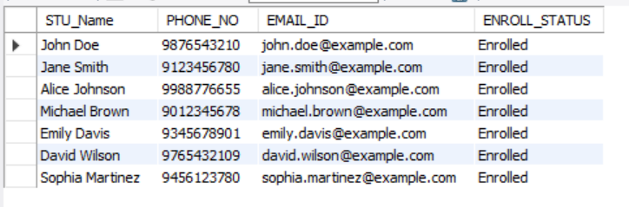

-- b) Write a query to retrieve a list of courses in which a specific student is enrolled.

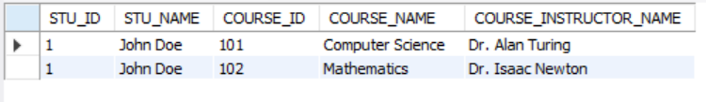

-- c) Write a query to retrieve course information, including course name, instructor information.

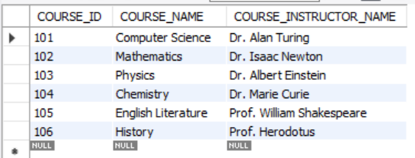

-- d) Write a query to retrieve course information for a specific course.

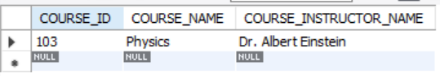

-- e) Write a query to retrieve course information for multiple courses.

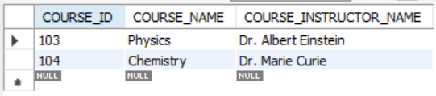

**-- 4) Reporting and Analytics (Using JOINING queries)**

-- a) Write a query to retrieve the number of students enrolled in each course

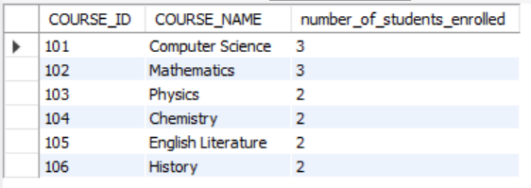

-- b) Write a query to retrieve the list of students enrolled in a specific course

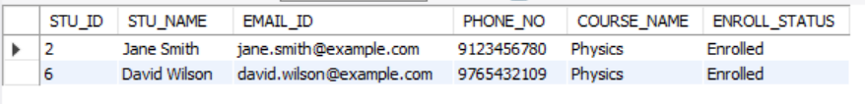

-- c) Write a query to retrieve the count of enrolled students for each instructor.

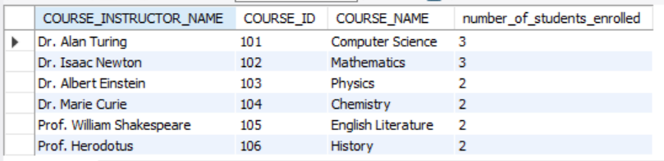

-- d) Write a query to retrieve the list of students who are enrolled in multiple courses

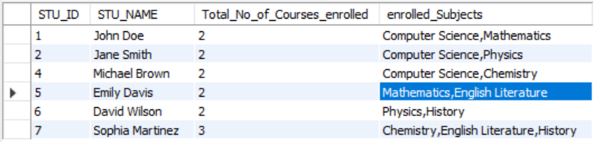

-- e) Write a query to retrieve the courses that have the highest number of enrolled students(arranging from highest to lowest)